Let's Read More Books

Final Prototype & Storyboard

## Part 1: Final Prototype

### <https://www.figma.com/file/YsOb2ZnNh2ibmx1c8Y9R9mts/HCI-Project?node-id=82%3A1>

**Changelog:**

Most of what we ended up changing for our project involved coloring in and polishing the look of our application. Based on the feedback we got, we showed what our application should look like with our books shown. We focused heavily on making the books stand out from the rest of the board, so we made the background a white, wood based texture that really contrasts most books. We also added colors to both the goal progress bars, which we hope will further differentiate the the long term goals from the short term goals. This is supposed to address one of the common issues we heard about, being that our application was too gray and lacked color. Functionally, we added an extra interaction in the profiles page, allowing users to click on the book they are currently reading in order to add their pages read. In response to some of the usability inconsistencies we found during our heuristic testing, we made the add book page distinct from the logging chapter page, which is now apparent when you select a new book vs when you add the new pages. Finally, we really wanted to make the achievements in the application pop, so we made the stars vibrant colors that should make them more appealing to the user, hopefully incentivizing them to read more.

## Part 2: Video Storyboard

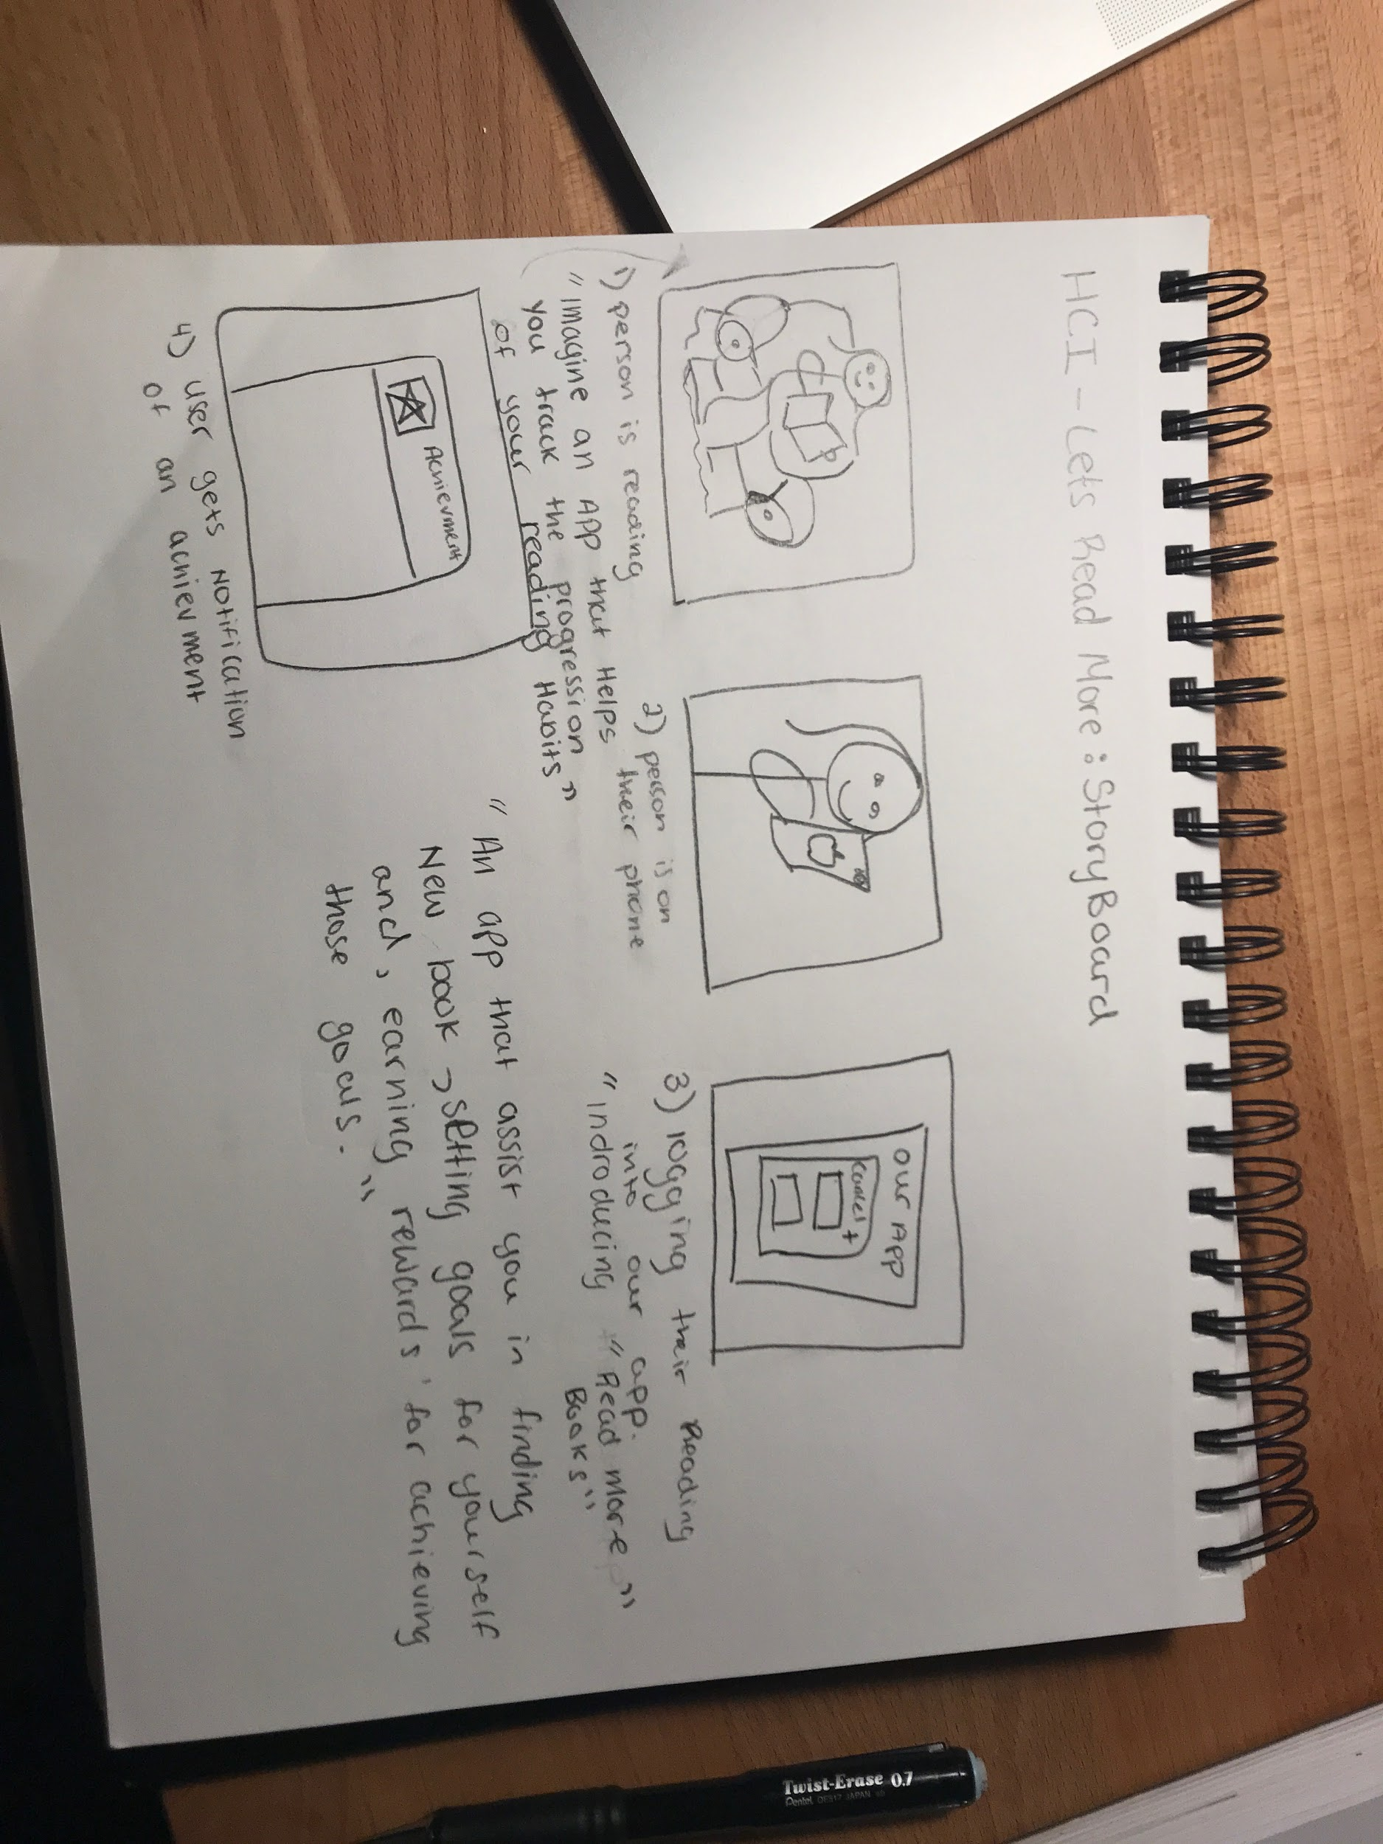

We ran out of time in class and didn't get a chance to present, so we didn’t get any feedback.